29.59: From Ampere’s law (Example 28.9), the magnetic field inside the wire, a distance from the axis, is 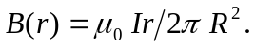
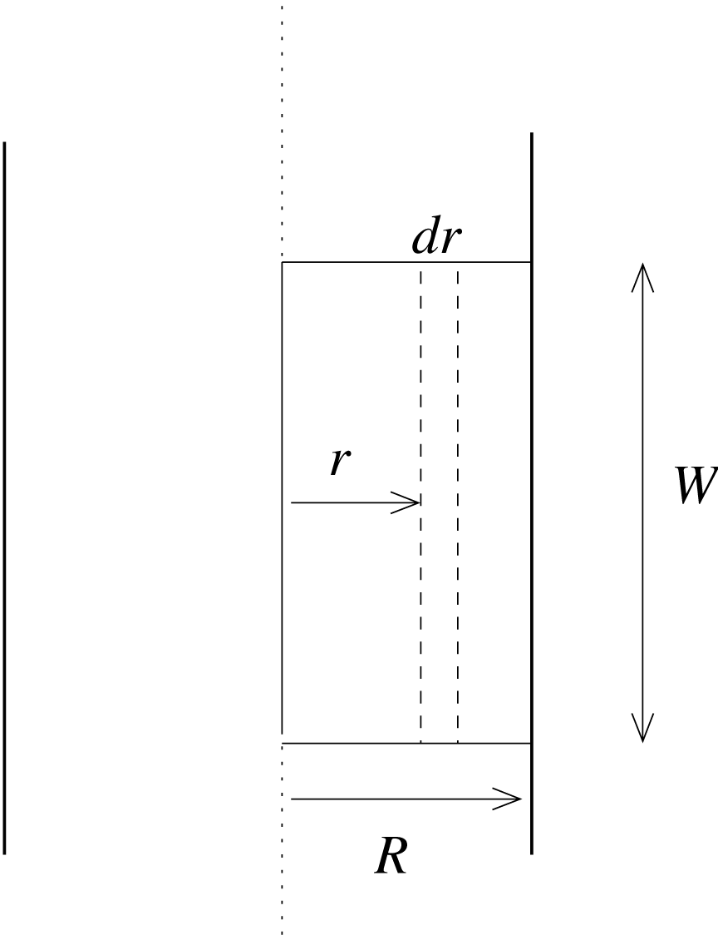 Consider a small strip of length W and width dr that is a distance r from the axis of the wire.
The flux through the strip is
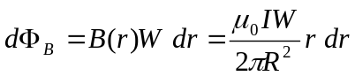
The total flux through the rectangle is

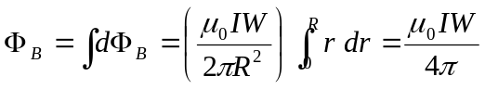

Note that the result is independent of the radius R of the wire.

